Docker Machine and Docker Compose Environments

Kirk S. Kalvar

Wednesday, February 25, 2015

# Overview

One of the nice things about docker machine and docker compose is how easy you can put together a somewhat sophisticated development sandbox without the need to download separate point products and cobble everything together. It provides easy startup and shutdown of that environment as well. I've attempted this feat with VMware Desktop and after a couple of virtual machines started it went downhill from there.

# Docker Machine Installation

## Download VirtualBox

Download Oracle VirtualBox for your platform

<https://www.virtualbox.org/wiki/Downloads>

## Download Docker Machine

Download Docker Machine

<https://docs.docker.com/machine/>

You need to setup your environment so the docker machine executable is on your PATH. Since I use Cygwin on Windows I also set an alias since the executable name is actually quite a bit longer than the documentation reference to ***docker-machine***.

## Create Docker Machine

docker-machine create --driver **virtualbox** dev

## VirtualBox Port Forwarding

In order to access from your desktop you need to add port 3000 to "port forwarding" setting for Virtual Machine in VirtualBox.

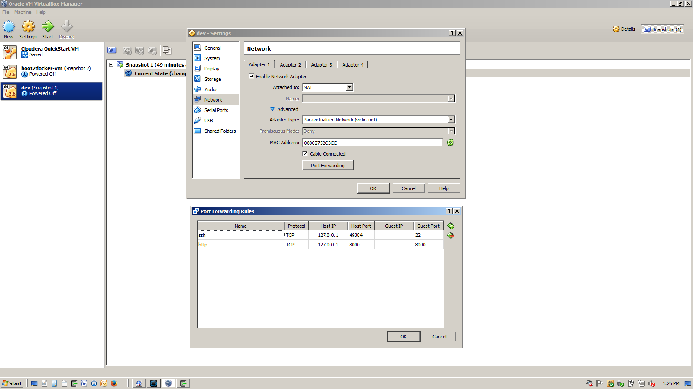

## VirtualBox Setting Up Shared Local Drive

To speed up the process we can share a local drive via VirtualBox and run scripts via the Docker VM

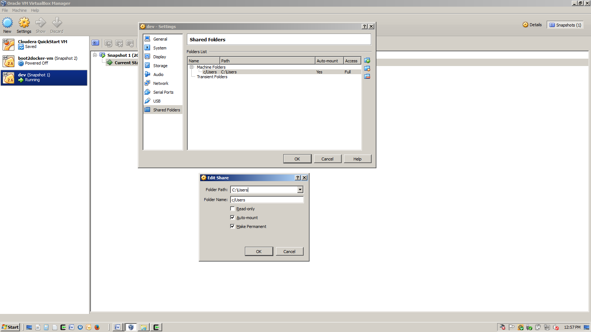

## Installing Docker Compose

docker-machine ssh dev

## Setting Up Docker Compose (Windows 7 hack)

Modify bootlocal.sh to create an alias every time the Docker VM starts.

sudo touch /var/lib/boot2docker/bootlocal.sh

sudo chmod 777 /var/lib/boot2docker/bootlocal.sh

sudo cat << EOF > /var/lib/boot2docker/bootlocal.sh

echo 'alias docker-compose='"'"'docker run \

-v \$(pwd):/app \

-v /var/run/docker.sock:/var/run/docker.sock \

-ti dduportal/docker-compose:latest'"'" >> /home/docker/.ashrc

EOF

## Poweroff and Restart Docker VM

# This will setup docker-compose as well as enable port forwarding/file sharing with the client machine

sudo poweroff

docker-machine start dev

docker-machine ssh

# Building MEAN

Placed the Dockerfile, docker-compose.yml and the mean directory in your windows home directory. The meanstack is a directory on your client machine where you have checked placed the following from github:

https://github.com/novamean/mean.git

https://github.com/kskalvar/mean-stack.git # Be sure to see README.md

cd /c/Users/kskalvar/meanstack

docker-compose up -d

# Testing MEAN

# Test from dev directly, and your client machine using curl

curl http://localhost:30000/

# docker-compose commands

docker-compose stop

docker-compose start

docker-compose restart

docker-compose rm

# Attach to Docker Container

docker exec -it app_mynode_1 bash